1. Quick Start Guide
   1. Equipment Configuration
      1. Device connection



Fig Front panel of KV-8000

[Equipment list]

・PC

・CPU unit: KV-8000

・Communication unit: KV-XL202

・Power unit: CA-U4

・Source meter: 2400s

・RS-232c cable (Need to cutting)

・USB cable

・Ethernet cable

・3-terminals power cable

Set the mode switch on the KV-8000 to PROG (Fig 1).

Connect the above devices as shown in Fig 2.

After cutting the RS-232c cable, attach the cut section to the KV-XL202 Port1. The RS-232c cable currently in use can be connected with the color pattern shown in the lower right of Fig 2. It is recommended that a continuity check be performed when changing cables.

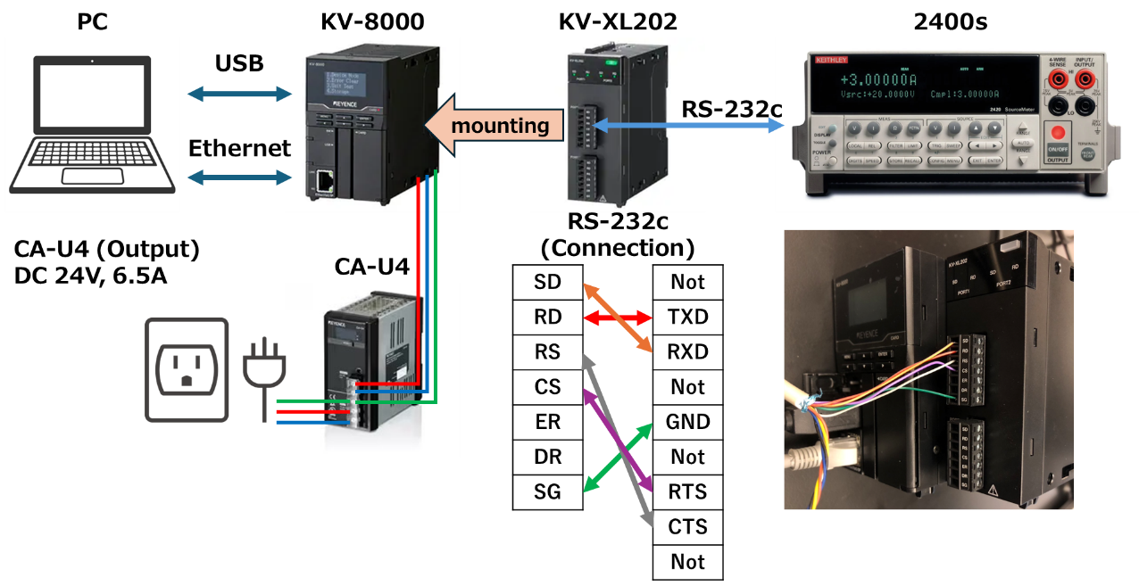

Fig Device connection

屋内, テーブル, ビデオ, ゲーム が含まれている画像

AI によって生成されたコンテンツは間違っている可能性があります。

Fig Photo of actual configuration

* + 1. 2400s Settings

[Communication settings]

1. Press the Menu button. (Fig4)
2. Select Communication and press Enter.
3. Select RS-232 and press Enter.
4. Select BAND and press Enter. Select 9600 and press Enter.
5. Select BITS and press Enter. Select 8 and press Enter.
6. Select PARITY and press Enter. Select EVEN and press Enter.
7. Select THERMINATOR and press Enter. Select <CR+LF> and press Enter.
8. Select FLOW-CTRL and press Enter. Select XON-XOFF and press Enter.
9. Press the Exit button twice to return.

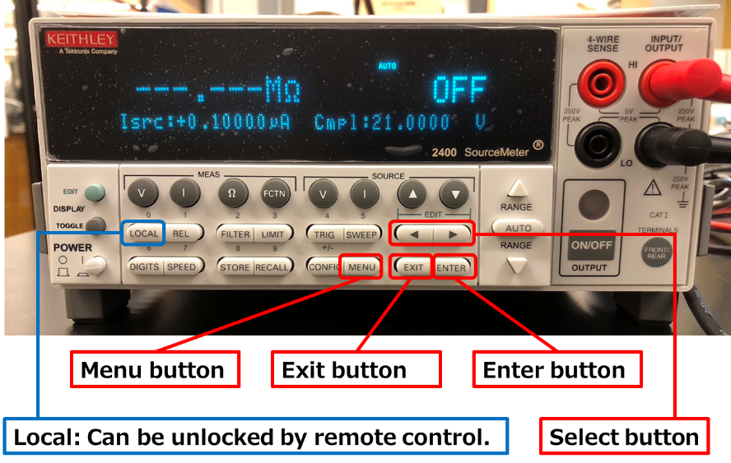

Fig Front panel of 2400s

* 1. Create KV-studio Project

1. Launch KV-studio.
2. Click on [File] -> [New project].
3. Enter Project name, PLC model, Project location. (Fig 5)
4. Click OK to create the project.
5. When the “Automatically set the operation recorder setting?” dialog box appears, select Yes. (*This setting is optional.)
6. When the “Setup unit setting info now?” dialog box appears, select No.

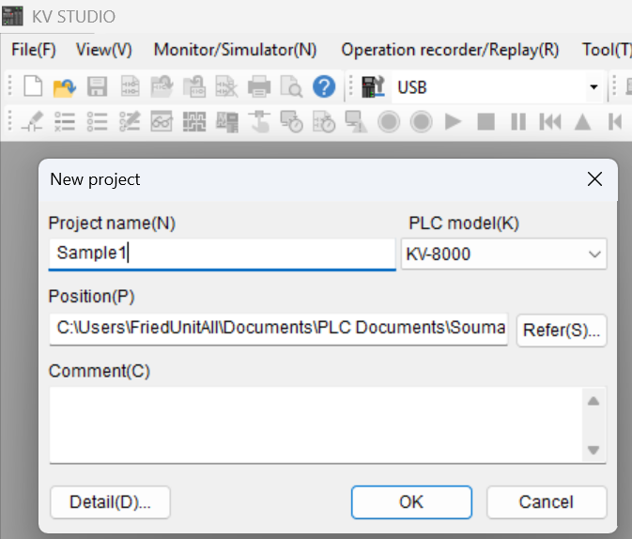

Fig Create New Project window

* 1. Configure PLC Settings

This time, only Port1 is to be set up for RS-232c communication of KV-XL202. Port can be configured in the same way, following the steps in 7 below.

1. Click on [Tool] -> [Clear PLC].
2. Clear PLC: Select a Clear All and Execute.
3. Project tree: Right click on [Unit configuration] -> Click on [Unit Editor].
4. Unit Editor: Click on [File] -> [Read Unit config. from PLC].
5. Unit Editor: When the “Unit settings are read in the initialization status.” Dialog box appears, select Yes.
6. Unit Editor: Select KV-8000 and Set [FTP server] to “Used”. (Fig 6)
7. Unit Editor: Select KV-XL202 and Change to the following settings. (Fig 7)

・Port1, Operation mode: Select “Non-procedure mode”.

・Port1, Device allocation: “DM”. (default)

・Port1, Interface: “RS-232C”. (default)

・Port1, Baudrate: “9600bps”. (Match with 2400s settings)

・Port1, Data bit length: “8 bits”. (Match with 2400s settings)

・Port1, Start bit: “1 bits”. (default)

・Port1, Stop bit: “1 bits”. (default)

・Port1, Parity: “Even”. (Match with 2400s settings)

・Port1, Checksum: “none”. (default)

・Port1, RS/CS flow control: “ON”. (Match with 2400s settings)

1. Unit Editor: Click on [Apply]. And click on [OK].

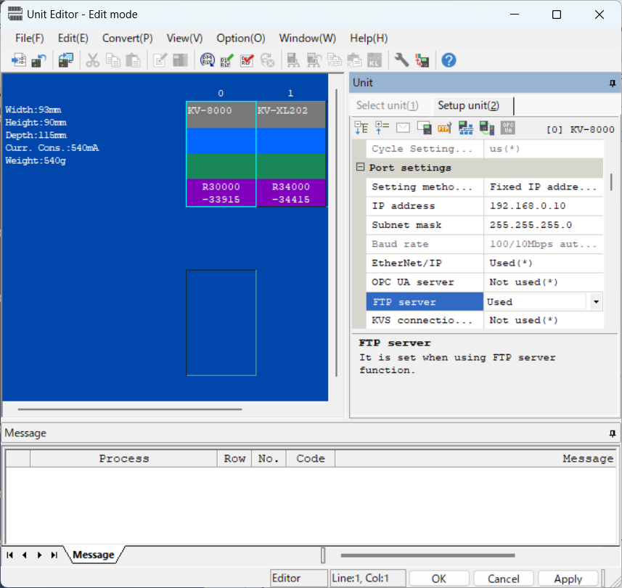

Fig Configuration of KV-8000

グラフィカル ユーザー インターフェイス

AI によって生成されたコンテンツは間違っている可能性があります。

Fig Configuration of KV-XL202

* 1. Register unit device

グラフィカル ユーザー インターフェイス, テキスト, アプリケーション

AI によって生成されたコンテンツは間違っている可能性があります。

Fig Device Comment

1. Click on [View] -> [Device comment edit window].
2. Device comment edit: Click on [Detail].
3. Device comment edit: Click on [Register unit device].
4. Register unit device: Select KV-8000 and KV-XL202.
5. Register unit device: Click on [Reg].
6. Device comment edit: Verify that the unit device is registered. And exit. (Fig 8)
   1. Create a Ladder Program

Import a basic program already created. The sample projects referenced exist in the following directories.

[Sample project]

C:\....\PLC_CommunicationTo2400S\Documents\Sample1\Sample1.kpr

1. Project tree: Right click on [Function Block] -> Click on [Import program].
2. Import program: Select the following file and click Open.

“C:\....\PLC_CommunicationTo2400S\Documents\Sample1\KvXl202_Status.kfb”

“C:\....\PLC_CommunicationTo2400S\Documents\Sample1\RS232c_Port1_CommunicationFunc.kfb”

”C:\....\PLC_CommunicationTo2400S\Documents\Sample1\RS232c_Port1_Initialize.kfb”

1. When the “Replace device assigned to unit” Dialog box appears, set the [Unit] item to KV-XL202. (Fig 9)
2. Project tree: Right click on [Standby module] -> Click on [Import program].
3. Import program: Select the following file and click Open.

“C:\....\PLC_CommunicationTo2400S\Documents\Sample1\RS232cP1_Measure.mod”

1. When the “Structure/Program selection” Dialog box appears, check to [To overwrite]. And click on Continue.
2. Project tree: Right click on [Every-scan execution] -> Click on [Import program].
3. Import program: Select the following file and click Open.

“C:\....\PLC_CommunicationTo2400S\Documents\Sample1\Main.mod”

1. When the “Structure/Program selection” Dialog box appears, check all to [To overwrite]. And click on Continue. (Fig 10)

グラフィカル ユーザー インターフェイス, テキスト, アプリケーション

AI によって生成されたコンテンツは間違っている可能性があります。

Fig Setting of Replace device

グラフィカル ユーザー インターフェイス, テキスト, アプリケーション

AI によって生成されたコンテンツは間違っている可能性があります。

Fig Structure selection Dialog

* 1. Transfer the Program to the PLC for Execution

1. Click on [Monitor/Simulator] -> [Transfer to PLC -> Monitor mode].
2. When the “PLC error: [No Ladder Program]” dialog box appears, click on Clear.
3. Transfer program: Click on Select all, and check to “Clear program/variable in PLC”.
4. Operation recorder save: Exit.
5. Set the mode switch on the front panel of KV-8000 to RUN (Fig 1).

グラフィカル ユーザー インターフェイス, アプリケーション

AI によって生成されたコンテンツは間違っている可能性があります。

Fig Transfer program

* 1. Monitor and Control

The program imported in Section 1.5 can read values with measurement settings previously made in the SourceMeter 2400s. This section describes how to monitor and control this PLC program in KV-studio.

1. Click on [Monitor/Simulator] -> [Monitor mode]. (Already done in Section 1.6)

・This allows device values to be monitored on the ladder program.

1. Turning on MeasModeP1Flag in the main program executes the measurement program of the standby module.
2. When MeasReadP1Flag is turned on and MeasModeP1Flag is turned on, the measurement program is repeated. When exiting, turn MeasReadP1Flag OFF. (Fig 12)
3. Click on [Monitor/Simulator] -> [Return to Editor], when you want to exit. (Fig 12)

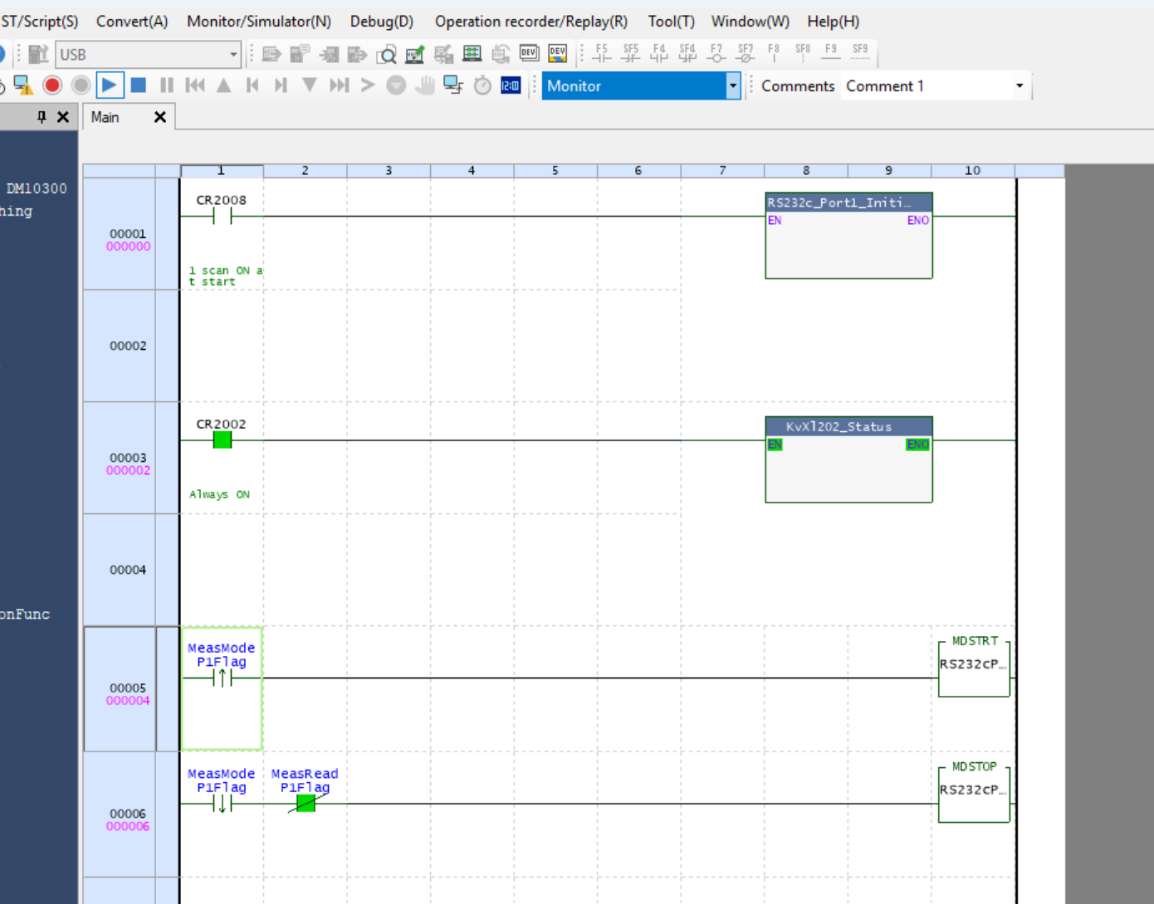

Fig Main Ladder Program